

Sri Lanka Institute of Information Technology Sri Lanka

B.Sc. (Hons) in Information Technology

**MODERN TOPICS IN INFORMATION TECHNOLOGY**

**(IT4020)**

Assignment Report

Assignment 01

# Declaration

We declare that this is our own work, and this proposal does not incorporate without acknowledgement any material previously submitted for a degree or diploma in any other university or Institute of higher learning and to the best of our knowledge and belief it does not contain any material previously published or written by another person except where the acknowledgement is made in the text.

|  |  |
| --- | --- |
| **Student ID** | **Student Name** |
| IT19015422 | Perera B.A.A.W.S |
| IT19015040 | Rasuni Wageesha H.A |
| IT18077698 | Thennakoon T.M.B.C.K |
| IT19011608 | Senanayaka S.A.M.A.B.M |

# Introduction

This is a plug-in project with numerous plug-ins that will connect together, as well as a producer who will produce services and consumers who will consume those services and make it available to the user. The Apache Felix Framework was used to construct this, which was installed and ran on the Eclipse Equinox platform.

This is for an Online Shopping store. Mainly, this online store has variety of categories.

* Men’s clothes section
* Women’s clothes section
* Kids clothes section
* Shoes section

User can go to each main sector and buy whatever they want based on their wishes. For this OSGi framework Men’s clothes, Women’s clothes, Kids clothes and shoes sections are the producers/services of this system. The consumer/subscriber of the system is online shop.

Main objective of this system is to provide a service for clients to buy the clothes online using this system.

Table of the Content

Declaration 2

Introduction 3

List of Figures 5

1. System Diagram 6

2. Manifest implementations 7

Online Kids Shop publisher (Producer/Service) 7

Online Men Shop publisher (Producer/Service) 7

Online Shoes publisher (Producer/Service) 8

Online Women’s Shop publisher (Producer/Service) 8

Kids Shop subscriber (Consumer/Subscriber) 9

Men Shop subscriber (Consumer/Subscriber) 9

Online shoes subscriber (Consumer/Subscriber) 10

Online womens subscriber (Consumer/Subscriber) 10

Integrated - Online shop subscriber (Consumer/Subscriber) 11

3. Bundles 12

Online Kids Shop publisher 12

Online Men Shop publisher 12

Online Shoes publisher 13

Online Women’s Shop publisher 13

Online Kids Shop Subscriber 14

Online Men Shop Subscriber 14

Online Shoes Subscriber 15

Online Women Shop Subscriber 15

Integrated - Online Shop Subscriber 16

4. Behavior and Outputs 17

Available bundles status 17

Outputs 19

# List of Figures

Figure 1.1: Overall System Diagram 6

Figure 2.1: Online Kids Shop publisher Manifest.mf file 7

Figure 2.2: Online Men Shop publisher Manifest.mf file 7

Figure 2.3: Online Shoes publisher Manifest.mf file 8

Figure 2.4: Online Women’s Shop publisher Manifest.mf file 8

Figure 2.5: Online kids Shop subscriber Manifest.mf file 9

Figure 2.6: Online Men Shop subscriber Manifest.mf file 9

Figure 2.7: Online shoes Subscriber Manifest.mf file 10

Figure 2.8: Online shoes subscriber Manifest.mf file 10

Figure 2.9: Online Shop subscriber Manifest.mf file 11

Figure 3.1 : Online Kids Shop publisher bundle 12

Figure 3.2: Online Men Shop publisher bundle 12

Figure 3.3: Online Shoes publisher bundle 13

Figure 3.4: Online Women’s Shop publisher bundle 13

Figure 3.5: Online Kids Shop Subscriber bundles 14

Figure 3.6:Online MenShop subscriber bundles 14

Figure 3.7: Online Shoes subscriber bundles 15

Figure 3.8: Online Women Shop subscriber bundles 15

Figure 3.9: Online Shop subscriber bundles 16

Figure 4.1: Available Kids Shop activated bundles 17

Figure 4.2: Available Men Shop activated bundles 17

Figure 4.3: Available Shoe Shop activated bundles 18

Figure 4.4: Available Women Shop activated bundles 18

Figure 4.5:intergrated all active bundles status 19

Figure 4.6: Output for kid clothes 19

Figure 4.7: Output for women clothes 20

Figure 4.8: Output for men clothes 20

Figure 4.9: Output for shoes 21

# System Diagram

Figure 1.1: Overall System Diagram

# Manifest implementations

## Online Kids Shop publisher (Producer/Service)

Figure 2.1: Online Kids Shop publisher Manifest.mf file

## Online Men Shop publisher (Producer/Service)

Figure 2.2: Online Men Shop publisher Manifest.mf file

## Online Shoes publisher (Producer/Service)

Figure 2.3: Online Shoes publisher Manifest.mf file

## Online Women’s Shop publisher (Producer/Service)

Figure 2.4: Online Women’s Shop publisher Manifest.mf file

## Kids Shop subscriber (Consumer/Subscriber)

Figure 2.5: Online kids Shop subscriber Manifest.mf file

## Men Shop subscriber (Consumer/Subscriber)

Figure 2.6: Online Men Shop subscriber Manifest.mf file

## Online shoes subscriber (Consumer/Subscriber)

Figure 2.7: Online shoes Subscriber Manifest.mf file

## Online Women shop subscriber (Consumer/Subscriber)

Figure 2.8: Online shoes subscriber Manifest.mf file

## Integrated - Online shop subscriber (Consumer/Subscriber)

Figure 2.9: Online Shop subscriber Manifest.mf file

# Bundles

## Online Kids Shop publisher

Figure 3.1 : Online Kids Shop publisher bundle

## Online Men Shop publisher

Figure 3.2: Online Men Shop publisher bundle

## Online Shoes publisher

Figure 3.3: Online Shoes publisher bundle

## Online Women’s Shop publisher

Figure 3.4: Online Women’s Shop publisher bundle

## Online Kids Shop Subscriber

Figure 3.5: Online Kids Shop Subscriber bundles

## Online Men Shop Subscriber

Figure 3.6:Online MenShop subscriber bundles

## Online Shoes Subscriber

Figure 3.7: Online Shoes subscriber bundles

## Online Women Shop Subscriber

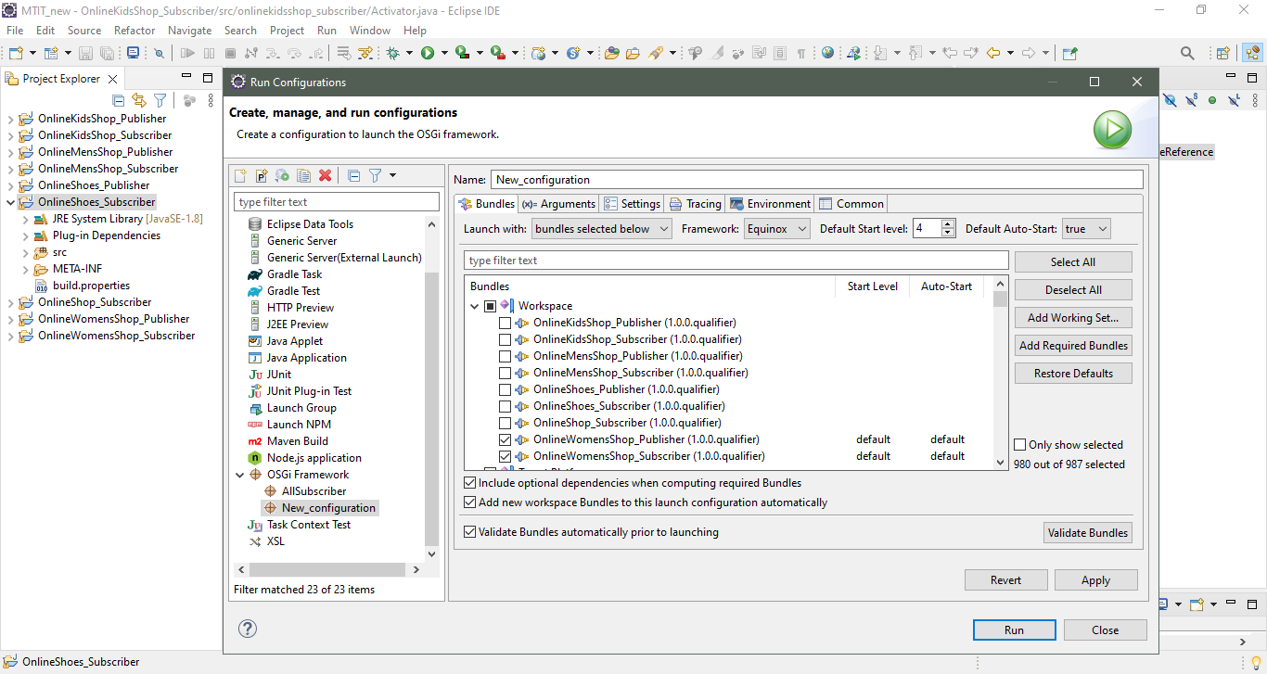

Figure 3.8: Online Women Shop subscriber bundles

## Integrated - Online Shop Subscriber

Figure 3.9: Online Shop subscriber bundles

# Behavior and Outputs

## Available bundles status

Figure 4.1: Available Kids Shop activated bundles

Figure 4.2: Available Men Shop activated bundles

Figure 4.3: Available Shoe Shop activated bundles

Figure 4.4: Available Women Shop activated bundles

Figure 4.5: Integrated all active bundles status

## Outputs

Figure 4.6: Output for kid clothes

Figure 4.7: Output for women clothes

Figure 4.8: Output for men clothes

Figure 4.9: Output for shoes